**Cold-chain Management system**

|  |  |  |
| --- | --- | --- |
| **Aqsa khalid**  [bscs15079@itu.edu.pk](mailto:bscs15079@itu.edu.pk) | **Zeeshan Iqbal**  [bscs15078@itu.edu.pk](mailto:bscs15078@itu.edu.pk) | **Muhammad Farooq**  [bscs15006@itu.edu.pk](mailto:bscs15006@itu.edu.pk) |

**M. Hamza Ittefaq Hafiz Asif Firdous**

[bscs14052@itu.edu.pk](mailto:bscs15078@itu.edu.pk)[bscs15029@itu.edu.pk](mailto:bscs15029@itu.edu.pk)

# ABSTRACT

In the daily life in medical field the drugs are very important and some of them are very expensive. All the drugs have a temperature range in which they do not spoil. When the temperature of the area or any place where we have placed the drugs is lower or higher than the specific range of drug it will be spoiled so it is very important to take care of the drug’s temperature. To take care of that we are trying to make a device which monitors the temperature of that area where the drugs are placed so that when the temperature of that area is gone low or high it will give a message and an alert. For the range of drugs, we did surveys from the different drugs centers and pharmacies to take reading in which temperature range of most drugs lies. So that in case of electricity failure or different reason by which the temperature of the place where we carry drugs goes away from the range, then some message is sent to specific person for savings drugs. In the project other features could be added on the base of customers’ need because we want to make our project a proper product for the medical field.

## Keywords

cold-chain, storage, medicines, drugs, vaccines, temperature, automation, stability of vaccines.

# BACKGROUND

Mistakes in storage can alter medication. So, it is very important to keep the critical medicines within WHO recommended temperature ranges. For this purpose, cold-chain handlers are appointed. They maintain a record of temperature for medicines such as vaccines with one hour interval. This paper suggests a technique which will automate this system in practice, which will eventually reduce man power. It will keep a record for temperatures on it's own, and generates an alert in the form of SMS if temperature falls from required temperature range.

# INTRODUCTION

In the pharmaceutical industry there are many types of medicines and some of them are temperature sensitive like in the case of vaccines. There are three temperature ranges in which different types of medicines are stored i.e. 2c˚-8c˚, 8c˚-15c˚ and below 25c˚. The medicines in the 2c˚-8c˚ category are the least temperature sensitive and are mostly vaccines which are stored in the refrigerator. If these medicines are not stored in given temperature, the efficacy of the medicine will be affected. There are some problems we face during the storage and monitoring of the medicines. We have to note temperature of the device which kept the medicines, we have to make records of the temperature readings, and there should be an alert system which give feedback when the temperature is not within the given conditions, and in the developed countries power supply cut off so we also have a backup system. This paper discusses about a device which solve these problems. It will note the temperature where the medicines are kept and if the temperature exceeds from the given conditions it will give an alert. The alerts are transferred to the person in different form like in form of message and buzzer sound. Our device is also maintaining records of the temperature readings. For recording the data we are using the mobile application services, we connect our device with the mobile application using the Wi-Fi module which record live readings of the device and also you can see that record using the mobile app. The alerts are also a part of our application.

# LITERATURE REVIEW

Temperature monitoring devices are crucial for ensuring safe and efficient patient care. It is very important to make sure that the drugs store in the medical unit are at right temperature because if no then it will decrease the efficacy of the drugs place in the pharma storage unit. Early in the start people use a mercury thermometer to measure the temperature of the pharma units in the pharmaceutical industry but it is very difficult to check the temperature again and again after small intervals of time. The mercury thermometer is dangerous to use in pharma unit because mercury is poisonous. The threat of mercury poisoning due to the usage of mercury in thermometers has always been a concern and it has led to the development of infrared and digital thermometers. Electronic temperature monitors, Infrared aural thermometers and temperature strips are the major product types in this market. Based on technology, temperature monitoring devices are mercury based or mercury free. Digital thermometers are preferred as they are faster, economical and more precise compared to other versions. They also make the temperature monitoring process easy and quick. Owing to the aforementioned reason digital thermometers account for the largest market share. The most popular version of technology presently in the market is battery operated flexible tip oral thermometers. People started use of digital thermometer technology in the pharma unit but these digital thermometers did not give any alerts and people have to see thermometer reading after a constant interval of time. For this need different companies start making advance temperature monitoring devices which give alerts when the temperature goes above and below from the certain range and some devices are also make records of these readings. Some of the devices available in market are “TempTime”, “Edgebridge”, “central environmental” monitoring for pharmacy and “medangel”. But these devices are not available in Pakistan and has to be import from another country. There is no such device available in Pakistan and the prices of that devices are very high. But the device we are makings is cost effective and has all the feature and some advance features which that expansive devices does not have. Our device gives alerts in your mobile app if the temperature goes away from the certain level and also make records and save it. You can also print that records in the hard form. It is very important to ensure that drugs have 100 percent efficacy because it’s the matter of life and dead.

## RESEARCH METHODOLOGY

***1- Interviews***

**1.1 Target audience**

We used a random and convenient sampling technique for interviewing. We interviewed from 11 pharmacies out of which 6 pharmacies had a hospital nearby.

**1.2 Interview Results and Analysis**

* No one had temperature logging system. Pharmacists do it manually.
* Temperature maintenance is totally dependent on duty person, whether it be a hospital or test lab.
* 2 out of 11 interviewers admitted that extreme conditions such as load shedding for a long time decreases the efficacy of medicines.
* The pharmacies which remain closed at night are more prone to loss of medicines as compared to those which remain open for 24 hours
* Worker’s strength is high but the reason is just to provide a better service to customers
* Almost everyone is using a software for record of medicines, also they are using an external device with refrigerator for record of temperatures
* Test labs such as of Shaukat Khanum are very concerned about maintaining specific temperature of samples for getting accurate results

**1.3 Summary**

We can automate the maintenance of record of temperatures for pharmacies. We can make a device for test labs so that they do not have to open the cooler after specific intervals for knowing if temperature is within the range or not.

## *2- Web-based Prototyping*

## 2.1 Low-fi Prototype

At first, we made a low-fi prototype of Web-based interface keeping in view the ease of use during office hours.

**2.2 Testing of low-fi Prototype**

When we visited the field for testing, it was found out that Website is easy to use but it does not fulfill the whole purpose. If Pharmacist is not physically present in pharmacy, and he is not logged in to the browser or not logged in to the email in worst case, then there is no way to inform him if Temperature goes out of range. So, Web-based Interface can be an additional functionality but we cannot totally rely upon it.

## *3- Mobile Application Prototyping*

## 3.1 Low-fi Prototyping

Design of Mobile Application was made keeping in view the effective Alert system for pharmacists. History must be available in different formats, so that pharmacist can easily search the record of any particular time interval.

## 3.2 Testing of low-fi Prototype

User was not able to understand the functions, they found it ambiguous and hard to use. Also a simple task required a number of screens when the user expected it to do it first.

## 3.2.1 Changes made due to evolution

The number of screens to do a specific task were reduced by prioritizing the tasks. Eliminating the tasks which most of users found to be unnecessary.

# 3.3 High-fi Prototype

All changes based on testing and ethnography are incorporated in the final design, to provide the best user experience by keeping things simple and easy to use.

## 3.3.1 Application’s main tasks

The main screen shows the introduction, purpose and usage of this mobile application as shown in the figure below:

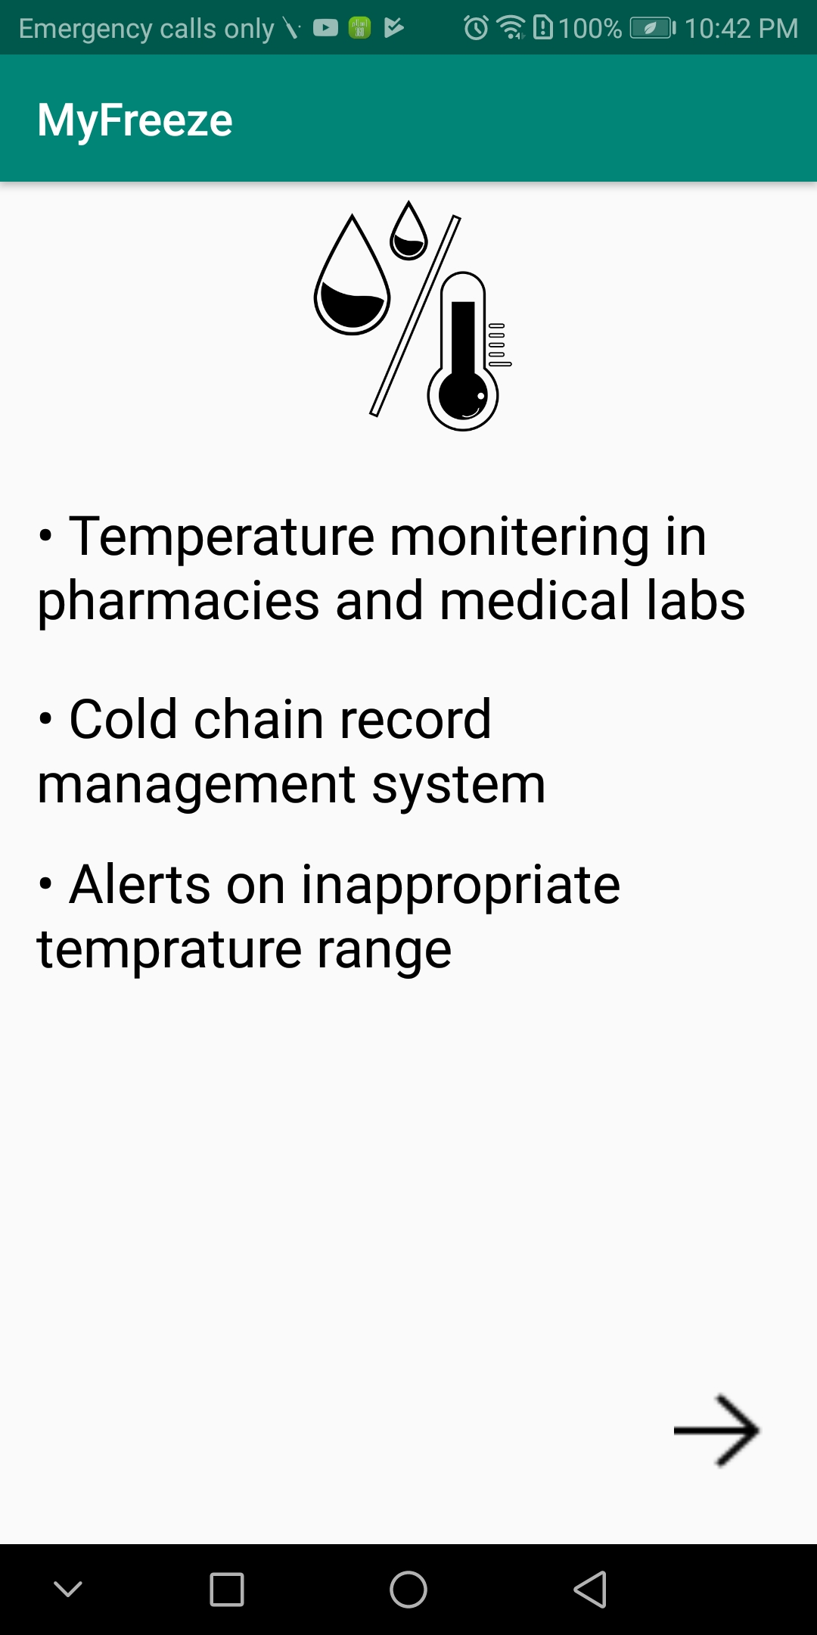

Once the user has decided to use this application, he is asked to give his mobile number, and mobile number is then verified as shown in figure below:

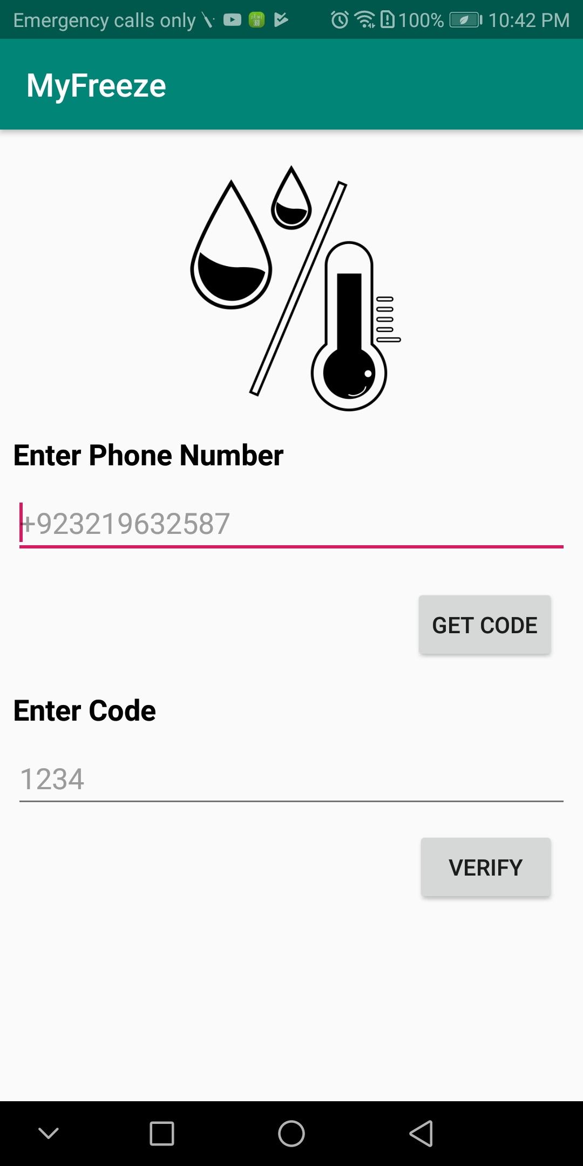

After verification of mobile number, the user is given the choice to add the devices. Or if he already had an account in past then his registered devices list are shown as below:

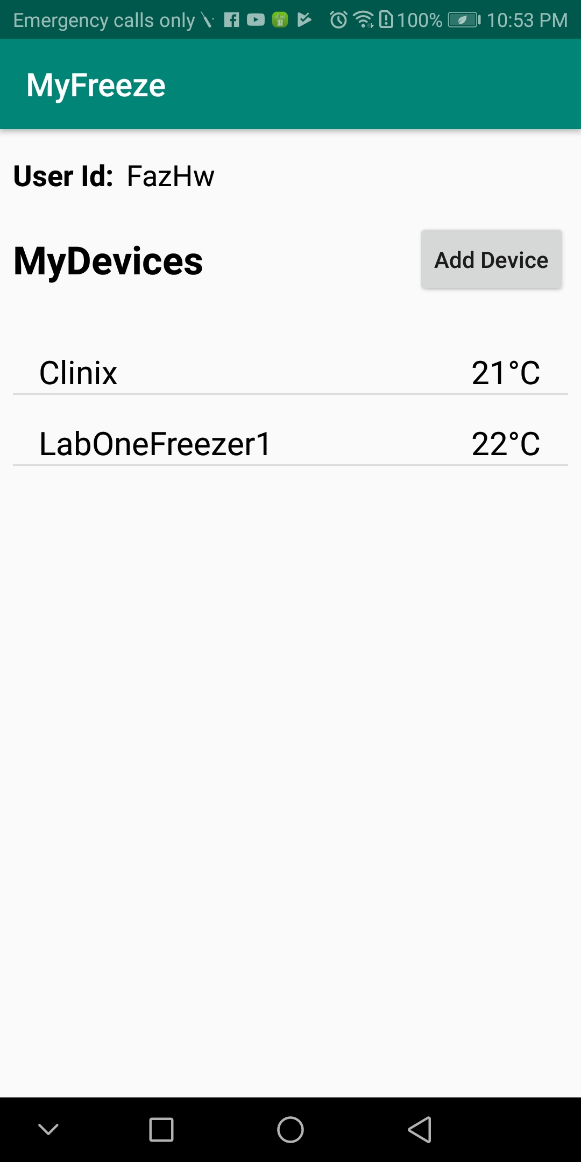

If no device had been registered then no data will be shown and user can add a device by clicking on add device button as shown in the figure below:

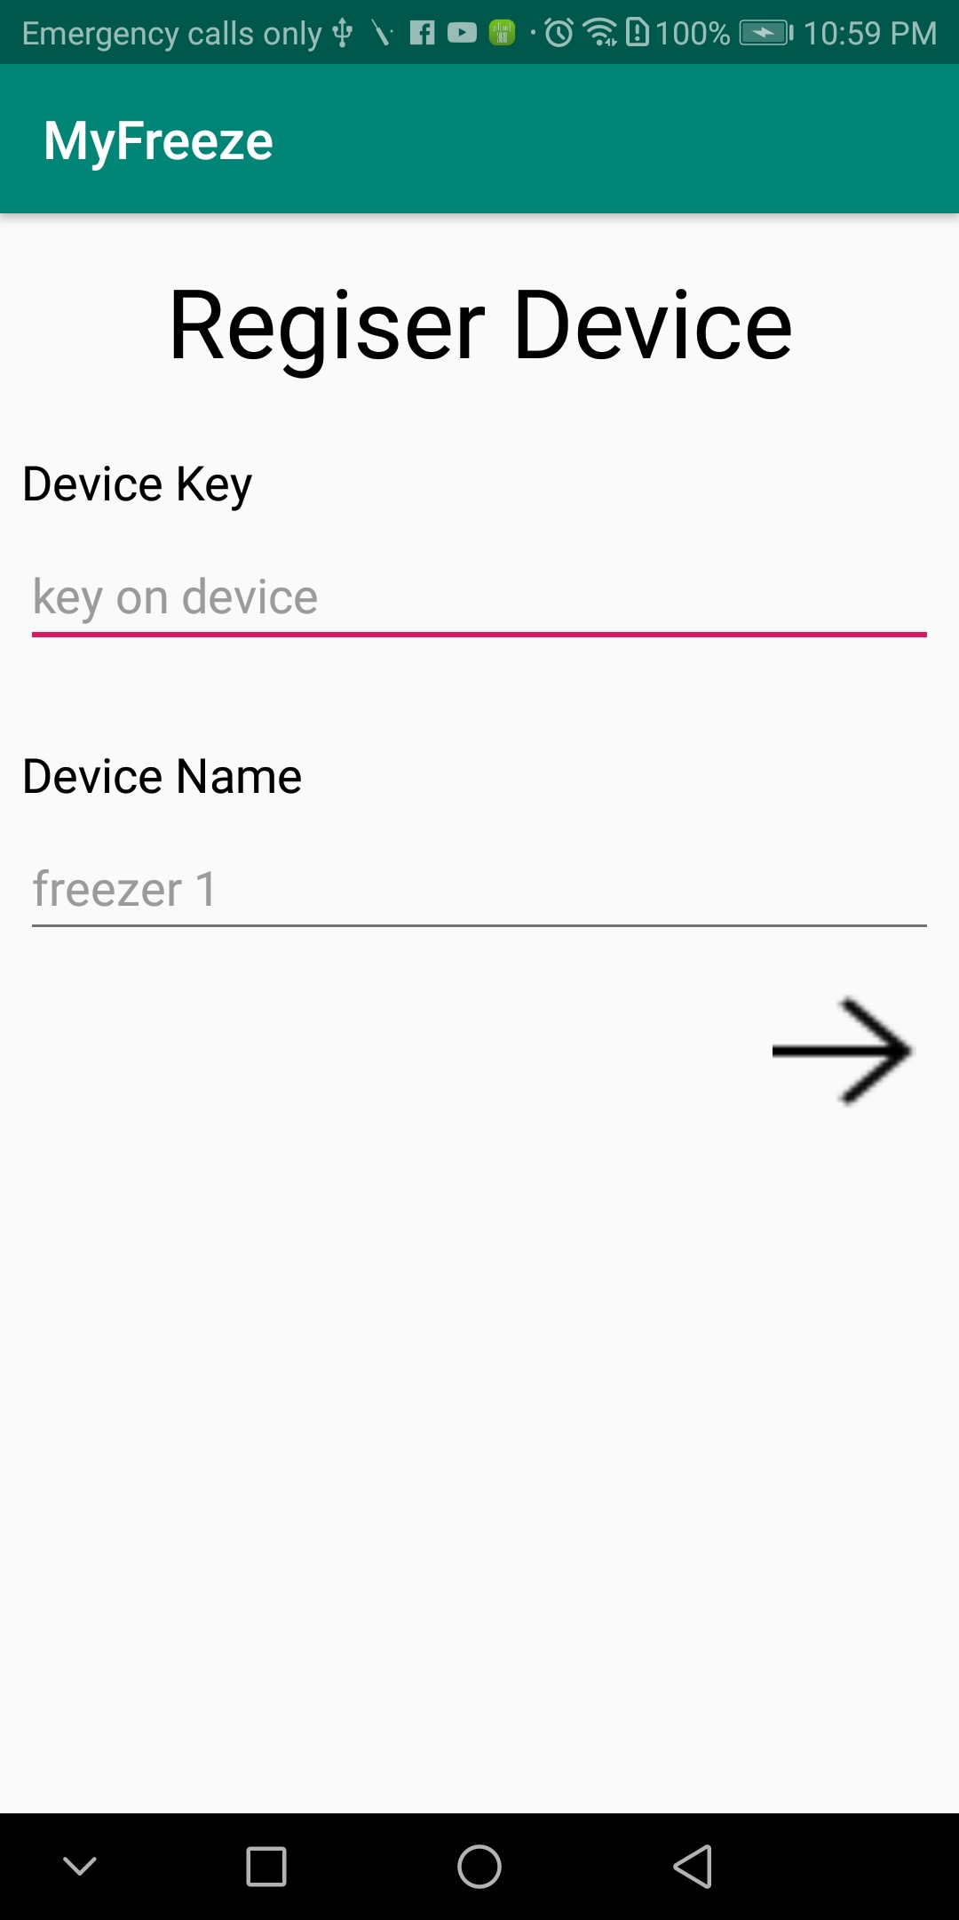

The final screen that now is always visible to user as long as he is logged in to his account is given below. It shows the list of registered devices. If user clicks on registered device, he can view all details of that particular device.

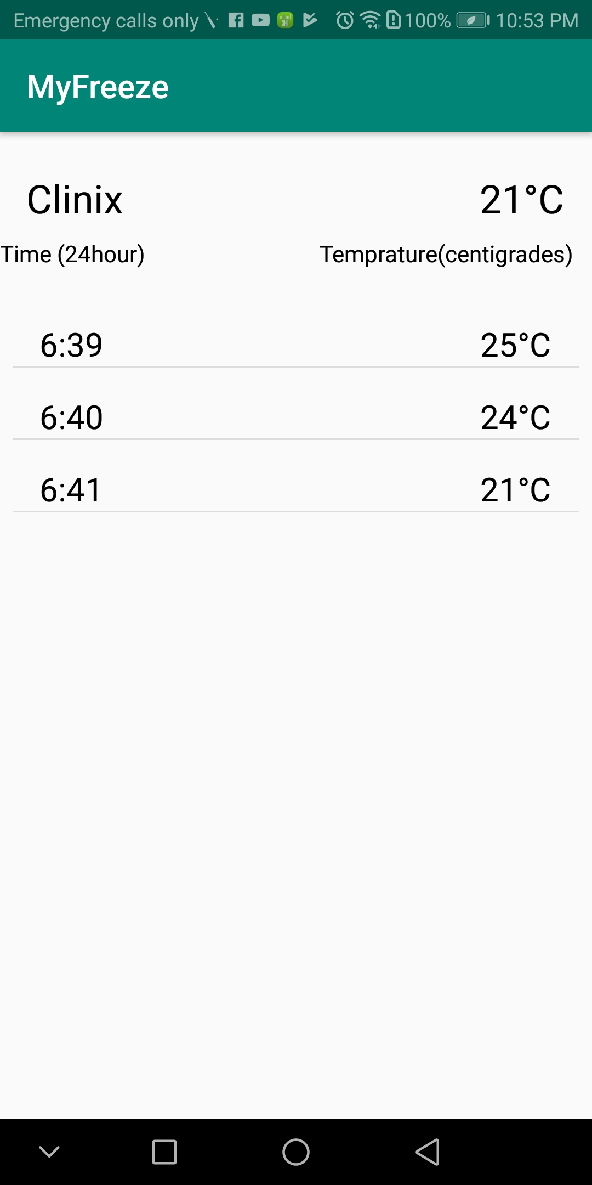

## 3.3.2 Future Additions

In future we want to implement this system with the additional functionality of search with respect to any specific time interval i.e. user will be able to filter out the records of any particular device at any particular time. In this way it will fulfill all the needs of Pharmacists in such a way that no manual recording is required, data of all times is saved on to the cloud database, and Pharmacists can show the record of temperature maintenance to higher authorities.

**3.3.2 Prototype implementation**

***Firmware Programming***

The tools used for Firmware programming are:

* VSCODE
* Platform.io as a plugin for VSCODE to compile build and upload the program.
* Arduino c++11 is used as Programming Framework.
* Git for version control

***Rationale of use***

Package of VSCODE + Platform.io provides a better intellisense code highlighting and make work smoother and faster. It is only a Development platform for embedded and IoT with intellisense. Arduino provides you with a wide range of libraries to reduce months of development into weeks and days.

***Components of Device***

* WeMos R1 D1 mini (single chip microcontroller with built-in WiFi shield)
* HC-06 (Bluetooth 2.0 module)
* DS18B20 (Waterproof temperature sensor) -10 to 80 C measuring range with +- 0.5 accuracy.
* 16x2 LCD + i2C module with display
* Wiro Board
* Small power bank for battery backup

***Mobile Application***

Android studio is used for development of Mobile Application and Firebase is used as Database.

***4- Usability Testing Results***

Things that was observed which was making disturbance are written below:

In Application

* User don’t know what to do with information provided at welcome page. It seems burden to read a paragraph.
* Due to low visual or animation, it takes time for user to see what to do at every step.
* Screen that shows the temperature logging seems halt. User asks now what to do. There should be a counter showing that e.g. after 20sec new value reading will come.
* ‘User id’ in ‘Add Device’ page was not making sense to any body

In Hardware Device

* User don’t know with the Wi-Fi connectivity of device. It should be descriptive about every phase as initializing, scanning, connected and not connected.
* Temperature out of range text should be more descriptive and show the problem.
* LCD used is very small. It is very difficult to know that what is going on. So it should be graphical or a large one.

# Conclusion

Keeping in view the behavior of pharmacies on low/medium scale, it is required that this kind of system must be implemented in order to ensure the best quality of medicines. Also in this way, the authorities can monitor the unbiased temperature ranges maintained at pharmacies.

# ACKNOWLEDGMENTS

We thank all Pharmacists who helped us in identifying the needs of Pharmacies, giving us a better insight of precautions needed to preserve medicines at their full effectiveness, and in testing of our device and mobile application.

# REFERENCES

1-<https://www.grandviewresearch.com/industry-analysis/temperature-monitoring-devices-market>